GOVERNMENT POLYTECHNIC, PUNE
(An Autonomous Institute of Government of Maharashtra)


A PROJECT REPORT
ON

"SmartAttendX – Smart And Secure Attendance System"
SUBMITTED BY

2306161 | Shreyash Sanjay Raut
2306186 | Dheeraj Somnath Swami
2306198 | Vishesh Vilas Waghmore
2306200 | Vivek Sandip Zadge

GUIDED BY
Smt. A. S. Paike

DEPARTMENT OF C OMPUTER ENGINEERING

(Academic Year: 2025-26)

GOVERNMENT POLYTECHNIC, PUNE
(An Autonomous Institute of Government of Maharashtra)

CERTIFICATE

This is to certify that

Shreyash Sanjay Raut | 2306161
Dheeraj Somnath Swami | 2306186
Vishesh Vilas Waghmore | 2306198
Vivek Sandip Zadge | 2306200

Has completed the necessary project work and prepared the bonafide on
“SmartAttendX – Smart And Secure Attendance System”
during the academic year 2025-26 of Third Year Diploma in Computer Engineering under the Government Polytechnic, Pune

Mrs. J. R. Hnage
Head Of Department
Dr. R. K. Patil
Principal

Smt. A. S. Paike
Project Guide External Examiner

ACKNOWLEDGEMENT

It gives us immense pleasure to present our project report on
“SmartAttendX – Smart And Secure Attendance System.”
We would like to express our heartfelt gratitude to Smt. Archana S. Paike, our project guide, for her invaluable guidance, constant encouragement, and continuous support throughout the development of this project. Her expert suggestions and motivation have been instrumental in the successful completion of our work.
We are sincerely thankful to Mrs. Jyoti R. Hange, Head of the Department of Computer Engineering,
and Dr. R. K. Patil, Principal of Government Polytechnic, Pune,
for providing us with the facilities and an environment conducive to the successful completion of our project.
We would also like to thank all the faculty members of the Computer Engineering Department for their constructive feedback and kind cooperation during the course of this project.
A special note of appreciation goes to our friends and classmates for their continuous encouragement, teamwork, and valuable suggestions that helped us refine our system and documentation.
Lastly, we are deeply grateful to our parents for their unconditional love, support, and motivation, which inspired us to put forth our best efforts.

- Shreyash Raut | (2306161)
- Dheeraj Swami | (2306186)
- Vishesh Waghmore | (2306198)
- Vivek Zadge | (2306200)

ABSTRACT

Attendance management plays a vital role in maintaining discipline, accountability, and efficiency within educational institutions and organizations. Traditional methods such as manual registers or RFID-based systems are often time-consuming, error-prone, and vulnerable to proxy attendance. To overcome these limitations, SmartAttendX – Face and Voice Recognition Based Smart Attendance Management System has been developed.
SmartAttendX automates the attendance process using AI-powered facial recognition and voice authentication, ensuring a dual-layer verification for enhanced accuracy and security. The system is built using Python (Flask) for the backend and HTML, CSS, and JavaScript for the frontend, providing a user-friendly web interface for administrators.
Each admin can register students, start attendance sessions, and monitor reports through an interactive dashboard. The system automatically marks students as absent initially and updates their status to present upon successful face and voice match. Additionally, the integrated Flask-Mail feature enables automatic email notifications to students and guardians, ensuring transparency.
All attendance data is securely stored in a SQLite database, allowing admins to view, analyze, and manage attendance history efficiently. SmartAttendX provides an accurate, contactless, and reliable attendance solution that reduces manual effort, prevents fraud, and enhances institutional efficiency.

INDEX

Sr. No | Contents |  | Page No.
 | Acknowledgement |  | I.
 | Abstract |  | II.
 | List of Figures |  | III.
 | List of Tables |  | IV.
 | List of Abbreviations |  | V.
1 | Introduction
 | 1.1 | Background
 | 1.2 | Problem Statement
 | 1.3 | Proposed Solution Goals and Objectives
2 | Literature Review
3 | Requirements Specification
 | 3.1 | Software Requirements
 | 3.2 | Hardware Requirements
 | 3.3 | Functional Requirements
 | 3.4 | Non - Functional Requirements
4 | System Design and Architecture
 | 4.1 | System Architecture Diagram
 | 4.2 | Data Flow Diagrams (Level 0, Level 1)
 | 4.3 | Use Case Diagram
 | 4.4 | Class Diagram
 | 4.5 | Sequence Diagram
 | 4.6 | Activity Diagram
5 | Feasibility Study
 | 5.1 | Economic Feasibility
 | 5.2 | Technical Feasibility
 | 5.3 | Operational Feasibility
6 |  | Implementation
 | 6.1 | Module Description
 | 6.2 | Technologies Used
 | 6.4 | Database Design
7 |  | Software Testing
 | 7.1 | What is Software Testing ?
 | 7.2 | Types of Testing
 | 7.3 | Test Cases
8 |  | Results and Discussion / Working of Software
9 |  | Advantages and Disadvantages
 | 9.1 | Advantages
 | 9.2 | Disadvantages
10 |  | Conclusion
11 |  | Future scope
12 |  | Reference

LIST OF FIGURES

Sr. No | Contents | Page No.
1.1 | System Architecture of SmartAttendX
1.2 | Workflow of SmartAttendX
4.1 | Level 0 Data Flow Diagram (DFD)
4.2 | Level 1 Data Flow Diagram (DFD)
4.3 | Use Case Diagram of SmartAttendX
4.4 | Class Diagram of SmartAttendX
4.5 | Sequence Diagram of SmartAttendX
4.6 | Activity Diagram of SmartAttendX
6.1 | Admin Dashboard Interface
6.2 | Student Registration Interface
6.3 | Attendance Recognition Window
6.4 | Attendance Summary View
6.5 | Email Notification Module
6.6 | Profile Management Page

LIST OF TABLES

Sr No. | Tables | Page No.
3.1 | Software Requirements
3.2 | Hardware Requirements
4.1 | Functional Requirements
4.2 | Non-Functional Requirements
6.1 | Database Structure (Admins Table)
6.2 | Database Structure (Students Table)
6.3 | Database Structure (Attendance Table)
7.1 | Test Case Summary
7.2 | Sample Test Cases for SmartAttendX
9.1 | Advantages and Disadvantages Summary

LIST OF ABBREVIATIONS

Abbreviation | Full form
AI | Artificial Intelligence
DFD | Data Flow Diagram
UI | User Interface
UX | User Experience
API | Application Programming Interface
SMTP | Simple Mail Transfer Protocol
DB | Database
ML | Machine Learning
FR | Face Recognition
TTS | Text-to-Speech
IDE | Integrated Development Environment
GUI | Graphical User Interface

CHAPTER 1

INTRODUCTION

BACKGROUND

Attendance management plays a vital role in maintaining discipline, accountability, and productivity in educational institutions and organizations. Accurate attendance data helps track student performance, ensure participation, and manage administrative records effectively. Traditionally, attendance has been taken manually by teachers or administrators using registers or spreadsheets. However, this method is time-consuming, error-prone, and often leads to proxy attendance or data manipulation.
With the rise of digital transformation and Artificial Intelligence (AI), institutions are shifting from manual systems to automated attendance solutions. Technologies like biometric verification, facial recognition, and voice authentication have revolutionized how attendance is tracked. These technologies not only enhance accuracy but also provide real-time monitoring and data analytics capabilities.
SmartAttendX leverages these modern technologies to build a dual-biometric attendance management system using face and voice recognition. The combination of these two methods makes attendance marking more secure and prevents impersonation or misuse. In addition, SmartAttendX provides a web-based admin dashboard where administrators can register students, manage attendance, and send automatic notifications. This system eliminates paperwork, improves efficiency, and creates a seamless attendance tracking experience.

PROBLEM STATEMENT

Despite the availability of biometric attendance systems, most existing solutions suffer from certain limitations.
Some of the key challenges observed in traditional and semi-automated attendance systems include:
- Manual attendance is slow, inaccurate, and can easily be manipulated.
- Single biometric systems such as fingerprint or face recognition alone are vulnerable to spoofing or environmental factors like lighting and camera quality.
- Lack of centralized and user-friendly dashboards for admins to manage records.
- No mechanism to notify students or guardians regarding attendance updates.
- Inability to analyze attendance trends, generate reports, or visualize data efficiently.
- Dependence on manual database updates that increase workload for staff.
- Such challenges highlight the need for an intelligent, secure, and multi-factor attendance system that not only automates attendance marking but also strengthens verification accuracy through multiple biometric layers. Moreover, real-time synchronization and data analytics are essential to make attendance management faster and more transparent.

PROPOSED SOLUTION GOALS AND OBJECTIVES

To address these limitations, the SmartAttendX system has been designed as an AI-powered, dual biometric attendance management system that utilizes face and voice recognition for identity verification. The system aims to automate the entire attendance process — from student registration to attendance reporting — with minimal human intervention.
Built using the Flask web framework, OpenCV, SQLite, and Flask-Mail, SmartAttendX provides a secure and scalable solution that can be used by multiple administrators simultaneously. Each admin can register their students, start attendance sessions, and manage attendance data through a single, intuitive dashboard.
When attendance begins, all students are initially marked absent by default. As the recognizer runs, students’ faces are detected using LBPH (Local Binary Pattern Histogram) face recognition. Upon a successful match, the system requests a voice verification sample. If the voice pattern matches the stored data, the student’s attendance is confirmed as present. This dual verification minimizes proxy attendance and ensures authenticity.
SmartAttendX also integrates email notifications that automatically inform students and guardians about attendance updates. The system further provides detailed attendance history, daily and monthly summaries, and visual analytics through interactive charts.
- Objectives Of SmartAttendX
- To develop an automated attendance system using face and voice recognition.
- To ensure accurate, secure, and tamper-proof attendance marking through dual biometric verification.
- To provide a web-based multi-admin dashboard for managing students and attendance data.
- To automatically notify students and guardians via email about attendance status.
- To store attendance data securely using SQLite and ensure easy access to historical records.

CHAPTER 2

LITERATURE REVIEW

2.1 EXISTING RESEARCH

The Over time, various attendance mechanisms have been developed to enhance efficiency and authenticity. Below is an overview of major systems in chronological order:

1. Manual Attendance Systems
Manual systems are the oldest and simplest, where attendance is recorded by hand in registers. While they require no technical setup, they are highly time-consuming, difficult to maintain, and error-prone. Teachers often waste valuable class time taking roll calls, and administrators struggle to verify authenticity in case of disputes.

2. Barcode and RFID-Based Attendance
Barcode and RFID (Radio Frequency Identification) systems automated attendance through scanning ID cards. Each student or employee is assigned a unique card or tag linked to their record in the database. Though faster than manual entry, RFID systems can be easily misused if cards are shared among users, and the need for specialized scanners makes the system hardware-dependent and costly over time.

3. Fingerprint-Based Attendance Systems
Fingerprint biometrics brought significant improvement in accuracy and reliability. The system authenticates users based on their unique fingerprint patterns. However, it suffers from hygiene issues (especially in post-pandemic conditions), and the fingerprint sensors require physical contact, making them unsuitable for large-scale or contactless environments. Moreover, in certain cases (e.g., worn fingerprints or sensor errors), attendance marking may fail.

4. Face Recognition-Based Systems
With the advancement of computer vision and AI, face recognition became a preferred contactless biometric method. Using algorithms like Haar Cascade, Eigenfaces, and LBPH (Local Binary Pattern Histogram), faces are detected and recognized in real-time through camera input. These systems are efficient and convenient but are still vulnerable to spoofing, such as using printed photos, and can be affected by lighting conditions, occlusions, or poor camera angles.

5. Voice Recognition-Based Systems
Voice recognition, or speaker verification, identifies individuals through unique vocal features such as tone, pitch, and frequency patterns. It enables contactless verification and adds an extra layer of security, especially when combined with another biometric. However, voice-only systems can be impacted by background noise, microphone quality, or voice changes due to illness.
Each of these systems contributes valuable insights into designing efficient attendance mechanisms. However, no single biometric method offers complete reliability and security under all conditions.

IMPACT OF AI ON PRODUCTIVITY

AI has revolutionized attendance management by replacing repetitive, manual tasks with intelligent automation. Machine learning algorithms enhance face detection accuracy, while voice recognition adds behavioral verification for stronger authentication.
In institutions, AI-based attendance systems like SmartAttendX improve operational productivity by:
- Reducing manual workload for faculty and administrators.
- Minimizing human errors in attendance marking.
- Ensuring faster and more reliable reporting.
- Enhancing transparency and accountability through automated records.
- Providing real-time access to attendance data anytime and anywhere.
AI-driven analytics can also identify attendance patterns, such as frequent absentees, enabling institutions to take early corrective measures. These advantages justify the growing adoption of multi-biometric systems worldwide.

CHAPTER 3

REQUIREMENT SPECIFICATION

  - SOFTWARE REQUIREMENTS

Sr. No. | Software Component | Specification / Description
1 | Operating System | Windows 10 / 11 or Linux (Ubuntu 20.04+)
2 | Programming Language | Python 3.9 or above
3 | Web Framework | Flask (Micro web framework for backend)
4 | Database | SQLite (Lightweight embedded database)
5 | Frontend Technologies | HTML5, CSS3, JavaScript
6 | AI/ML Libraries | OpenCV, NumPy, Librosa, Pyttsx3,  Face_Recognition, Pytorch
7 | Audio Processing Libraries | Sounddevice, Soundfile
8 | Mailing Service | Flask-Mail (SMTP integration for notifications)
9 | IDE / Code Editor | Visual Studio Code / PyCharm
10 | Version Control | Git & GitHub for code management
11 | Browser | Google Chrome
12 | Visualization Tools | Chart.js for attendance data visualization

  - HARDWARE REQUIREMENTS

Sr. No. | Hardware Component | Specification / Description
1 | Processor | Intel Core i3 or higher (64-bit)
2 | RAM | Minimum 8 GB recommended
3 | Storage | 512 GB HDD or 128 GB SSD (for fast data access)
4 | Webcam | 720p or higher resolution (for facial recognition)
5 | Microphone | Standard built-in or USB mic (for voice verification)
6 | Monitor | 15.6” or larger, minimum 1366x768 resolution
7 | Internet Connection | Stable broadband / Wi-Fi for email notifications
8 | Power Supply | Standard uninterrupted power connection
9 | Peripheral Devices | Keyboard and Mouse for admin interaction

  - FUNCTIONAL REQUIREMENTS

ID | Requirement Description | Priority (Must/Want)
FR1 | The system must allow multiple admins to register and log in securely. | Must
FR2 | Admin should be able to add, edit, or delete student records. | Must
FR3 | The system should support real-time face recognition for attendance marking. | Must
FR4 | The system should perform voice authentication immediately after face recognition. | Must
FR5 | Attendance should be stored automatically in the database with date and time. | Must
FR6 | Admin should be able to view, filter, and analyze attendance history. | Must
FR7 | The system should send email notifications to students and guardians about attendance. | Must
FR8 | Admin should be able to reset data (attendance, students, or entire database) via dashboard. | Must
FR9 | The dashboard should display attendance statistics and graphs. | Want
FR10 | The system should provide an option for theme switching (dark/light mode). | Want
FR11 | The system should allow profile management for each admin (name, email, photo). | Want
FR12 | Attendance records should be exportable (CSV / PDF). | Want

  - NON-FUNCTIONAL REQUIREMENTS

ID | Non-Functional Requirement | Description
NFR1 | Performance | The system should process facial and voice recognition within 5 seconds per user.
NFR2 | Usability | The web interface should be responsive, simple, and user-friendly for admins.
NFR3 | Scalability | The system should support multiple admins and hundreds of students efficiently.
NFR4 | Security | Sensitive data (emails, passwords) should be securely stored using encryption and session management.
NFR5 | Reliability | Attendance records should be accurately saved even in case of temporary internet loss.
NFR6 | Availability | The system should operate 24/7 with minimal downtime.
NFR7 | Maintainability | The modular Flask architecture should allow easy debugging and updates.
NFR8 | Portability | The application should run on Windows and Linux without modification.
NFR9 | Compatibility | Must be compatible with modern browsers and webcams.
NFR10 | Data Integrity | The system must prevent duplicate student entries and incorrect data insertion.

CHAPTER 4

SOFTWARE COMPONENTS

SYSTEM ARCHITECTURE

The architecture of SmartAttendX is based on a three-tier model consisting of:
- Presentation Layer (Frontend):
  - Built using HTML, CSS, and JavaScript, this layer provides the user interface for admins to log in, register students, and view attendance dashboards.
  - It communicates with the backend using HTTP requests through the Flask framework.
- Application Layer (Backend):
  - Implemented in Python using Flask, this layer handles all business logic, authentication, and system operations.
  - It manages modules for student registration, attendance processing, email notifications, and data management.
- Data Layer (Database):
  - The SQLite database stores all the records, including admin credentials, student details, attendance logs, and email addresses.
  - It ensures data persistence, accuracy, and integrity.

Figure 4.1: System Architecture of SmartAttendX

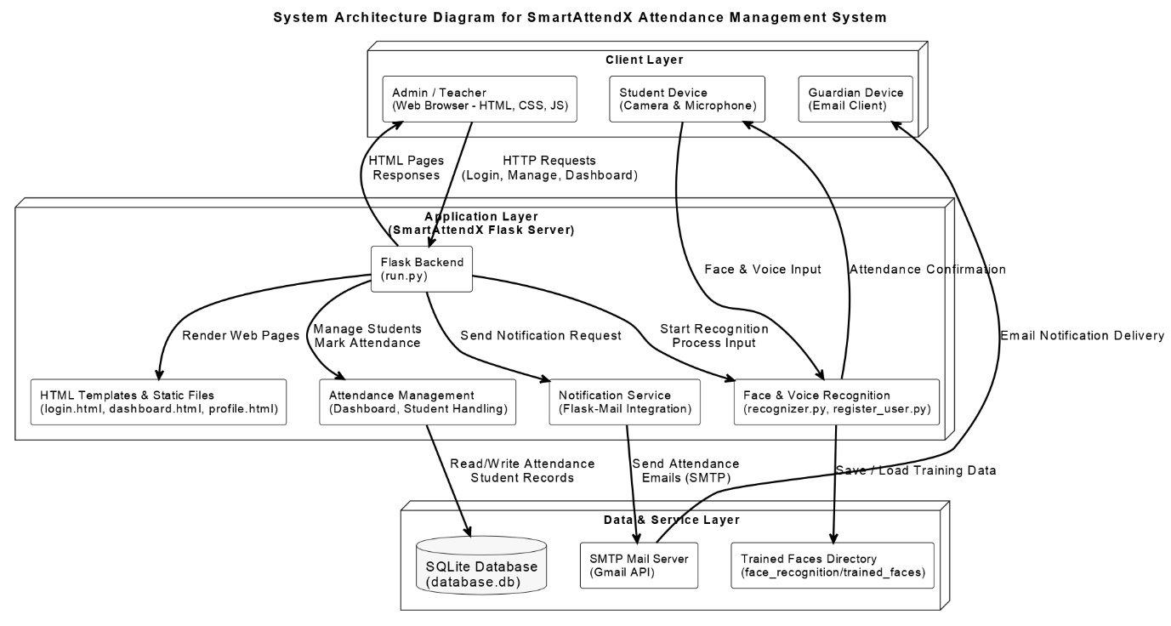

This architecture ensures efficient data flow, real-time processing, and modular separation between components.

DATA FLOW DIAGRAM

Figure 4.2: Level 0 DFD

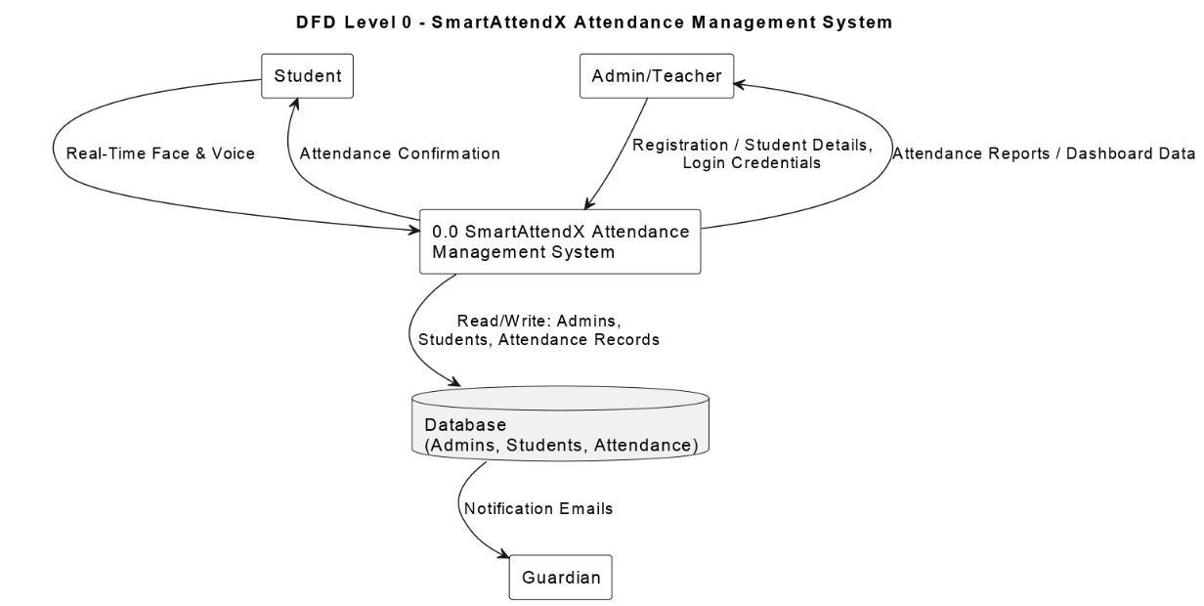

The Level 0 DFD provides a high-level overview of the SmartAttendX system. The Admin interacts with the system to register students, start attendance, and view reports. The system accesses the database to store attendance and uses the mail service to send notifications.

Figure 4.3: Level 1 DFD

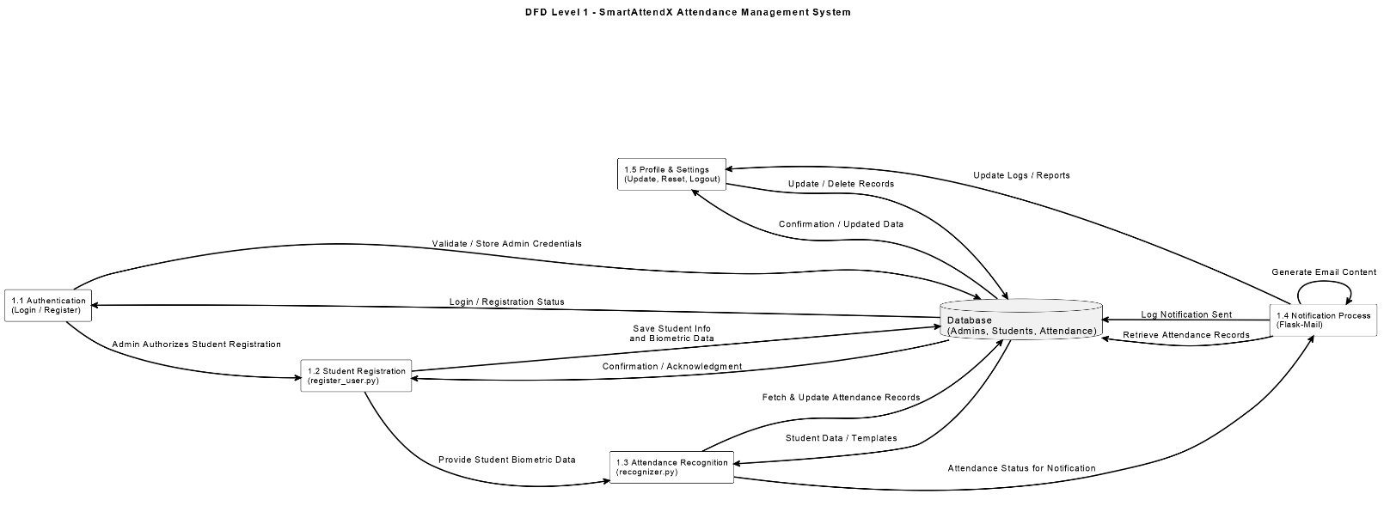

Level 1 DFD depicts the internal working of SmartAttendX. The admin triggers attendance through the dashboard. The system sequentially performs face recognition, voice verification, updates the database, and sends emails to concerned recipients.

USE CASE DIAGRAM

Figure 4.4: Use Case Diagram for SmartAttendX

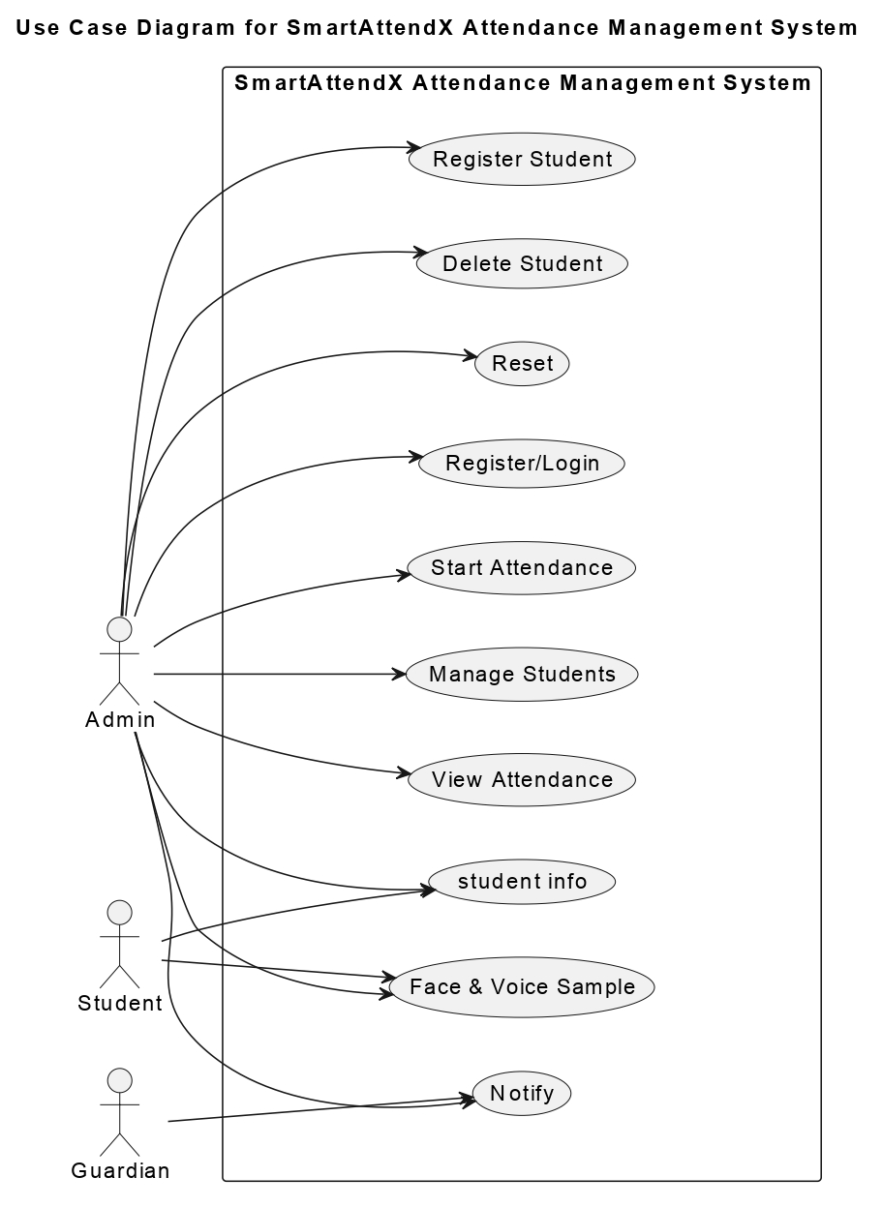

- Admin: Manages attendance and records through the dashboard.
- Student: Recognized by the system using camera and microphone.
- Guardian: Receives attendance notifications via email.

CLASS DIAGRAM

Figure 4.5: Class Diagram of SmartAttendX

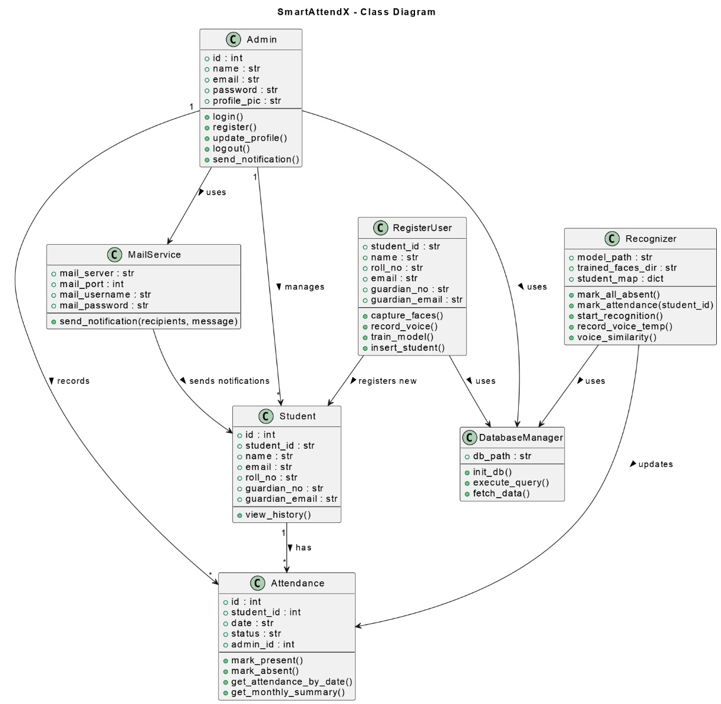

The Admin, Student, and Attendance classes represent key database entities. Admins manage students, and attendance is linked to both through foreign key relationships.

SEQUENCE DIAGRAM

Figure 4.6: Sequence Diagram of SmartAttendX

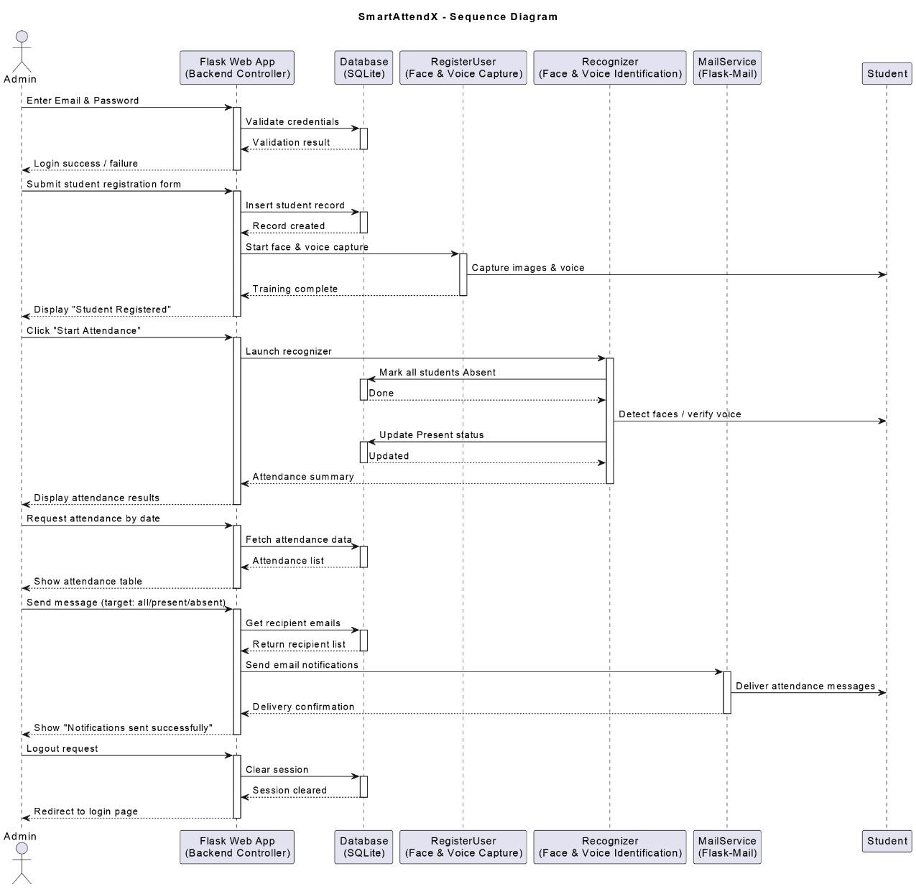

The admin initiates attendance via the dashboard. The Flask app triggers face recognition followed by voice authentication. Once confirmed, attendance is recorded and emails are dispatched.

ACTIVITY DIAGRAM

Figure 4.7: Activity Diagram of SmartAttendX

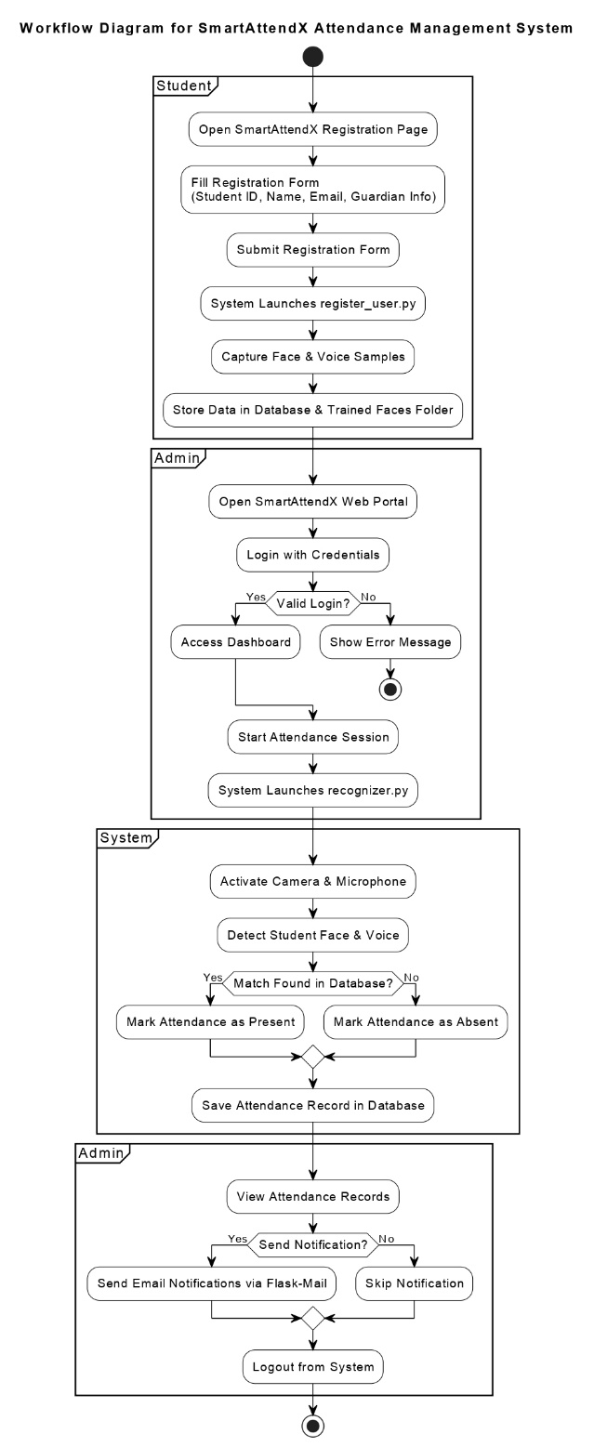

The activity diagram outlines the logical flow of actions — from admin login, student registration, and recognition to data update and notification dispatch.
CHAPTER 5

FEASIBILITY STUDY

5.1 TECHNICAL FEASIBILITY

The technical feasibility assesses whether the proposed system can be developed with the available hardware, software, and technical expertise.
SmartAttendX is developed using modern yet lightweight technologies such as Python, Flask, Face_Recognition, and SQLite. These technologies are open-source and compatible across platforms, reducing dependency on commercial licenses or expensive infrastructure.

Key Technical Factors:
- Programming Language: Python 3.9+ (easy to learn, versatile, and well-suited for AI applications).
- Framework: Flask (lightweight, flexible web framework ideal for modular development).
- Face Recognition: Implemented using Face_Recognition
- Voice Authentication: Achieved through Librosa and Cosine similarity comparison for robust speaker verification.
- Database: SQLite ensures fast, lightweight, and file-based data storage.
- Email Notifications: Managed through Flask-Mail using SMTP integration.
- Hardware: Runs smoothly on standard systems with an inbuilt webcam and microphone.
- Platform Compatibility: Works across Windows and Linux operating systems.
- The technical stack chosen for SmartAttendX is reliable, scalable, and proven to handle biometric and web-based operations efficiently.

Advantages of Technical Feasibility:
- Uses cross-platform technologies.
- Enables quick maintenance and debugging due to modular architecture.

ECONOMIC FEASIBILITY

The economic feasibility determines whether the cost of developing and maintaining the system is justified by its benefits.
SmartAttendX is designed to be cost-effective since it utilizes free and open-source technologies. Institutions do not require additional hardware beyond standard webcams and microphones already available in most classrooms and offices.

Cost Estimation Overview
Expense Type | Description | Estimated Cost (INR)
Hardware | Basic PC with webcam and microphone | ₹0 (existing)
Software Tools | Python, Flask, OpenCV, SQLite, Flask-Mail (open-source) | ₹0
Development Environment | IDE (VS Code / PyCharm Community Edition) | ₹0
Internet & Hosting | For email and testing (local deployment possible) | ₹500 – ₹1,000
Maintenance | Occasional updates / debugging | ₹500
Total Estimated Cost |  | ₹1,000 – ₹1,500 (approx..)

Benefits:
- Saves hundreds of hours spent on manual attendance.
- Reduces administrative workload and human errors.
- Eliminates the need for physical records.
- Enhances transparency through automatic email reporting.
- In comparison to commercial biometric systems (which may cost ₹20,000–₹50,000), SmartAttendX is a low-cost, high-value solution, making it economically feasible and sustainable for long-term use.

5.3 OPERATIONAL FEASIBILITY

Operational feasibility assesses whether the system meets user needs and functions efficiently in its intended environment.
The SmartAttendX system is highly user-friendly and designed for non-technical administrators and teachers.
It provides a clean and intuitive dashboard interface, requiring minimal training for operation. The system simplifies daily attendance processes, allowing users to manage tasks in a few clicks.

Operational Highlights:
- Ease of Use: Admins can easily log in, add students, start attendance, and view statistics.
- Automation: Dual biometric recognition ensures zero manual intervention.
- Accuracy: The combined face and voice authentication minimizes the possibility of proxy attendance.
- Communication: Automatic email alerts to students and guardians improve accountability.
- Security: Password-protected admin access ensures data privacy.
- Maintenance: Simple to maintain due to modular Flask architecture.
The system can be easily deployed in schools, colleges, training institutes, or corporate environments. It significantly reduces paper usage and enhances digital transformation.

User Acceptance:
Initial testing and demonstrations have shown that teachers and administrators find SmartAttendX intuitive, accurate, and time-saving. Since it uses simple hardware and web-based tools, user adoption is expected to be seamless.
Thus, SmartAttendX is operationally feasible and aligns with institutional digitalization goals.

CHAPTER 6

IMPLEMANTATION

6.1 MODULE DESCRIPTION

1. Admin Module
The Admin Module is responsible for managing access, authentication, and administrative functions.
It allows the admin to register, log in, update profile information, and perform all system operations through a secure dashboard.
Features:
  - Secure login/logout using Flask sessions.
  - Register multiple admins independently.
  - Manage and update profile information (name, email, photo).
  - Each admin manages only their own students and records.
Purpose:
Ensures secure, multi-admin functionality and prevents unauthorized access.

2. Student Registration Module
This module enables admins to register students and capture their biometric data.
When a student is registered:
    - Details like name, email, roll number, guardian contacts are stored in the database.
    - The script register_user.py runs automatically to capture:
      - 20 face images using the face_recognition library.
      - 1 voice sample (voice.wav) using the sounddevice library.
    - Facial encodings are generated and stored for later matching.
    - Features:
    - Simple and guided GUI using tkinter popups.
    - Stores face encodings and voice samples for every student.
    - Automatic model training and saving in /trained_faces/.
Purpose:
Prepares the system with biometric data for real-time recognition.

3. Attendance Recognition Module
This is the core of SmartAttendX — responsible for dual biometric verification.
Working:
  - Admin starts attendance from the dashboard.
  - The recognizer.py script:
- Marks all students Absent for the day initially.
- Captures video frames using the system camera.
- Uses the face_recognition library to:
- Detect faces in frames.
- Generate encodings for each face.
- Compare with stored encodings to identify students.
- After successful face recognition, the system prompts the student to speak.
- The voice is compared with stored audio using MFCC features and Cosine Similarity.
- If both verifications pass, attendance is marked Present.
- Real-time audio feedback is provided using pyttsx3.
Purpose:
Ensures accurate, contactless, and secure attendance through dual biometric verification.

4. Notification Module
This module handles automated communication using Flask-Mail.
Functions:
- Sends daily attendance summaries via email to:
    - All students
    - Present students
    - Absent students
- Emails are also sent to guardians.
- Allows custom notifications or announcements.
Purpose:
Enhances transparency and communication between institution, students, and guardians.

5. Dashboard and Reporting Module
The web dashboard provides all the controls and analytics for the admin.
Features:
- View total students, daily attendance, and trends.
- Filter records by date or student name.
- Display attendance statistics in charts using Chart.js.
- Provides options to reset data, manage profiles, and toggle themes (dark/light mode).
Purpose:
Offers an intuitive interface for real-time control and performance monitoring.

  - TECHNOLOGICAL USED

1. Programming Language
- Python 3.9+ – The core development language used for both backend and biometric modules.
- Advantages: Easy to learn, vast AI/ML library support, and cross-platform compatibility.

2. Web Framework
- Flask Framework – A lightweight Python framework used to build the backend and connect the database, dashboard, and recognition modules.
- Handles admin login, routing, sessions, and notification APIs.

3. Libraries and Tools

Library / Tool | Purpose / Functionality
face_recognition | Deep learning-based facial recognition and encoding (built on Dlib CNN models).
Flask-Mail | Used for sending attendance emails and notifications.
SQLite | Lightweight local database for persistent data storage.
Librosa | Extracts MFCC (Mel Frequency Cepstral Coefficients) for voice verification.
Cosine Similarity | Measures similarity between live and stored voice features.
pyttsx3 | Provides text-to-speech feedback (e.g., “Attendance marked for…”)
sounddevice / soundfile | Record and save voice samples during registration.
Chart.js | Displays attendance data graphically on the dashboard.
HTML, CSS, JavaScript | Used for designing and structuring the web interface.
tkinter | Popup-based GUI interface for face and voice registration.

4. Hardware Requirements

Component | Specification
Processor | Intel Core i3 or higher
RAM | Minimum 8 GB
Storage | 128 GB SSD / 512 GB HDD
Camera | 720p or higher resolution
Microphone | Built-in or USB external mic
Internet | Required for email notifications

5. Software Stack Overview

Layer | Technology Used | Description
Frontend | HTML, CSS, JS | User Interface
Backend | Python Flask | Application Logic
AI Engine | face_recognition, Librosa | Biometric Recognition
Database | SQLite | Data Storage
Communication | Flask-Mail (SMTP) | Email System

  - DATABASE DESIGN

The database for SmartAttendX is implemented using SQLite, ensuring lightweight, fast, and portable data management.
It consists of three main relational tables: admins, students, and attendance.

1. Admins Table
Field | Type | Description
id | INTEGER (Primary Key) | Unique admin ID
name | TEXT | Admin name
email | TEXT | Unique admin email
password | TEXT | Encrypted password
profile_pic | TEXT | File path of uploaded profile photo

2. Students Table
Field | Type | Description
id | INTEGER (Primary Key) | Unique student ID
student_id | TEXT | Unique institutional ID
name | TEXT | Student’s full name
roll_no | TEXT | Roll number
email | TEXT | Student email
guardian_no | TEXT | Guardian contact number
guardian_email | TEXT | Guardian’s email
admin_id | INTEGER (Foreign Key) | References the admin who added the student

3. Attendance Table
Field | Type | Description
id | INTEGER (Primary Key) | Attendance record ID
student_id | INTEGER (Foreign Key) | References student in Students table
date | TEXT | Date of attendance (YYYY-MM-DD)
status | TEXT | Present / Absent
admin_id | INTEGER (Foreign Key) | References the related admin

4. Entity Relationship (ER) Summary
Relationships:
- One Admin → Many Students
- One Student → Many Attendance Records
This relational design ensures proper data organization and quick data retrieval.

CHAPTER 7

SOFTWARE TESTING

7.1 WHAT IS SOFTWARE TESTING
Software testing is a critical phase in the Software Development Life Cycle (SDLC) that ensures the developed application meets its functional and performance requirements. It involves executing the software to identify errors, defects, or any deviations from the expected behavior.
The main objective of software testing is to verify that the system works as intended, is reliable under different conditions, and delivers a smooth user experience.
Testing helps improve software quality, ensures accuracy, enhances performance, and minimizes post-deployment issues.
Testing in SmartAttendX focuses on verifying both:
  - Functional correctness (e.g., accurate attendance marking, email notifications).
  - Non-functional quality attributes (e.g., speed, usability, and reliability).
By conducting proper testing, SmartAttendX ensures the dual biometric system (face + voice recognition) performs efficiently and securely under real-world conditions.

7.2 TYPES OF TESTING

Different testing techniques were used to validate various components of SmartAttendX.
Below are the main types of testing conducted during development:

1. Unit Testing
Unit testing involves testing individual modules or components in isolation to ensure they function correctly. For example:
  - Testing the login validation function.
  - Verifying the face recognition comparison logic returns correct results.
  - Ensuring the voice matching function produces consistent accuracy.

2. Integration Testing
Integration testing checks whether different modules interact correctly when combined.
Examples include:
  - Linking the face recognition module with the database.
  - Ensuring attendance data is saved correctly after recognition.
  - Testing integration between Flask-Mail and the notification module.

3. Functional Testing
This testing ensures all features of SmartAttendX operate as per user requirements.
For example:
  - Admin registration and login.
  - Student registration and biometric data capture.
  - Attendance marking workflow (face + voice).
  - Email notifications sent after recognition.

4. Performance Testing
Performance testing checks how efficiently the system operates under typical usage conditions.
In SmartAttendX, the average recognition and verification time per student was tested to ensure smooth execution.

Goal: The system should recognize a student and mark attendance within 5 seconds.

5. Usability Testing
Usability testing evaluates how user-friendly and intuitive the system interface is.
SmartAttendX was tested for ease of navigation, visual clarity, and accessibility for non-technical users such as teachers and staff.

6. Security Testing
Security testing ensures that sensitive data such as admin credentials and attendance records are protected from unauthorized access.
Session handling, password storage, and restricted access to admin dashboards were verified to ensure robust security.

7. Regression Testing
After updates or bug fixes, regression testing ensures that previously working modules (like login and recognition) still function properly without new errors.

8. User Acceptance Testing (UAT)
This final phase validates the system from an end-user perspective.
Teachers and test users verified:
  - Successful login and profile management.
  - Smooth attendance marking.
  - Accuracy of daily and monthly reports.
The users confirmed that SmartAttendX met their needs and expectations.

7.3 TEST CASES FOR SMARTATTENDX

Test ID | Test Case Description | Expected Result | Actual Result | Status
TC01 | Admin Registration | New admin account created successfully | Admin account created | ✅ Pass
TC02 | Admin Login | System verifies credentials and grants access | Dashboard displayed | ✅ Pass
TC03 | Invalid Login | Invalid credentials show error | Error message shown | ✅ Pass
TC04 | Add Student | Student record stored with valid details | Record added in database | ✅ Pass
TC05 | Duplicate Student ID | System rejects duplicate student ID | Warning displayed | ✅ Pass
TC06 | Face Recognition | Recognizes registered student face correctly | Face matched successfully | ✅ Pass
TC07 | Unknown Face | Unregistered face not recognized | “Unknown” displayed | ✅ Pass
TC08 | Voice Verification | Verifies student voice successfully | Voice matched accurately | ✅ Pass
TC09 | Voice Mismatch | Voice mismatch leads to rejection | “Voice mismatch” message | ✅ Pass
TC10 | Attendance Marking | Marks attendance as Present after dual verification | Status updated in DB | ✅ Pass
TC11 | Duplicate Attendance | Prevents duplicate attendance for same student | Message: “Already marked” | ✅ Pass
TC12 | Email Notification (All) | Sends emails to all students and guardians | Email sent successfully | ✅ Pass
TC13 | Email Notification (Absent Only) | Sends only to absent students | Correct recipients received email | ✅ Pass
TC14 | Attendance Report View | Displays date-wise attendance summary | Table loads correctly | ✅ Pass
TC15 | Monthly Statistics | Pie chart updates with correct data | Graph rendered accurately | ✅ Pass
TC16 | Reset Data Option | Deletes selected data safely | Confirmation alert shown | ✅ Pass
TC17 | Theme Toggle | Switch between dark and light mode | Interface updated instantly | ✅ Pass
TC18 | Profile Update | Updates admin info and profile picture | Changes saved successfully | ✅ Pass
TC19 | Network Failure Handling | System handles mail failure gracefully | Displays mail error message | ✅ Pass
TC20 | Logout | Clears session and redirects to login | Logout successful | ✅ Pass

CHAPTER 8

RESULT AND DISCUSSION/WORKING OF SOFTWARE

The overall workflow of SmartAttendX is shown below, illustrating how the modules interact sequentially to complete attendance marking and reporting.

1. Step-by-Step Working:
- System Initialization: The Flask application is launched. The system loads all modules — face recognition, voice authentication, database connection, and Flask-Mail.
- Admin Login: The administrator logs into the web dashboard by providing a registered email and password.
Secure Flask sessions are created to maintain authentication.
- Dashboard Display: After login, the admin is redirected to the dashboard showing:
- Total registered students
- Present and absent counts
- Buttons for starting attendance, registering new students, and sending notifications.
- Student Registration: The admin enters new student details and submits the registration form. The system automatically triggers the register_user.py script to:
- Capture 20 face samples using the webcam.
- Record one voice sample (3–4 seconds).
- Store data in the /trained_faces/ directory and database.
- Retrain the model for recognition.

  - Starting Attendance: Admin clicks “Start Attendance”, which executes recognizer.py.
  - Opens the webcam.
  - Detects faces using the face_recognition library.
  - Compares live encodings with stored encodings.
  - Identifies students with a confidence threshold.
  - Voice Authentication: Once the face is recognized, the system prompts the student to speak.
  - The live voice is recorded and compared using MFCC features and cosine similarity.
  - If similarity ≥ 0.75, the student’s attendance is confirmed.
  - Attendance Update:
  - The database updates the student’s record as “Present” for the current date.
  - Pyttsx3 engine provides audio feedback (e.g., “Attendance marked for Roll No. 198 – Vishesh Waghmore”).
  - The student’s name and status are displayed in the recognizer window.
  - Email Notification: After attendance, the admin can send instant notifications through the dashboard. The system uses Flask-Mail to deliver personalized attendance reports to students and their guardians.
  - Viewing Reports: Admin can view daily or monthly attendance through:
  - Tabular views
  - Pie charts and bar graphs (Chart.js)
  - Individual student history (month-wise)
  - Logout and Session Clear: When the admin logs out, the session is cleared securely, preventing unauthorized access.

2. System Outputs:

- Home Page:

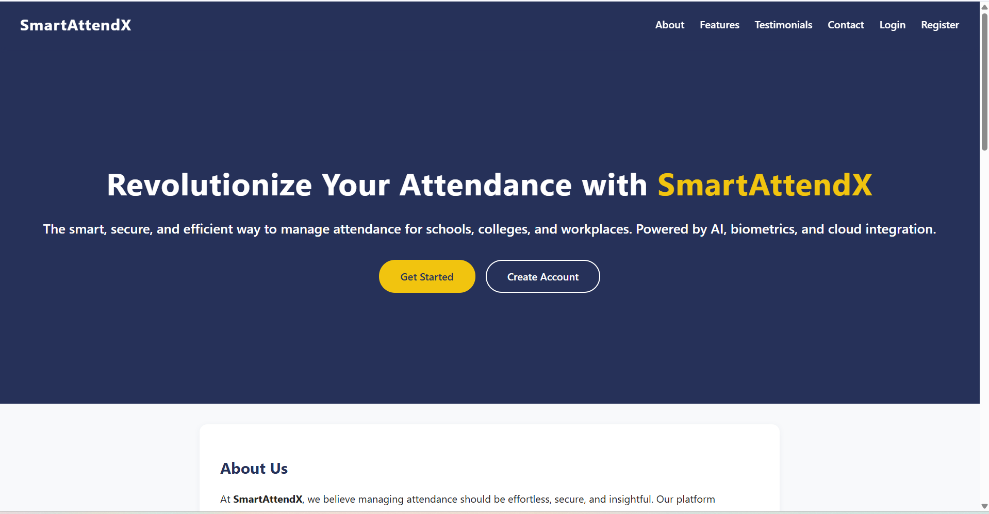

- Login Page:

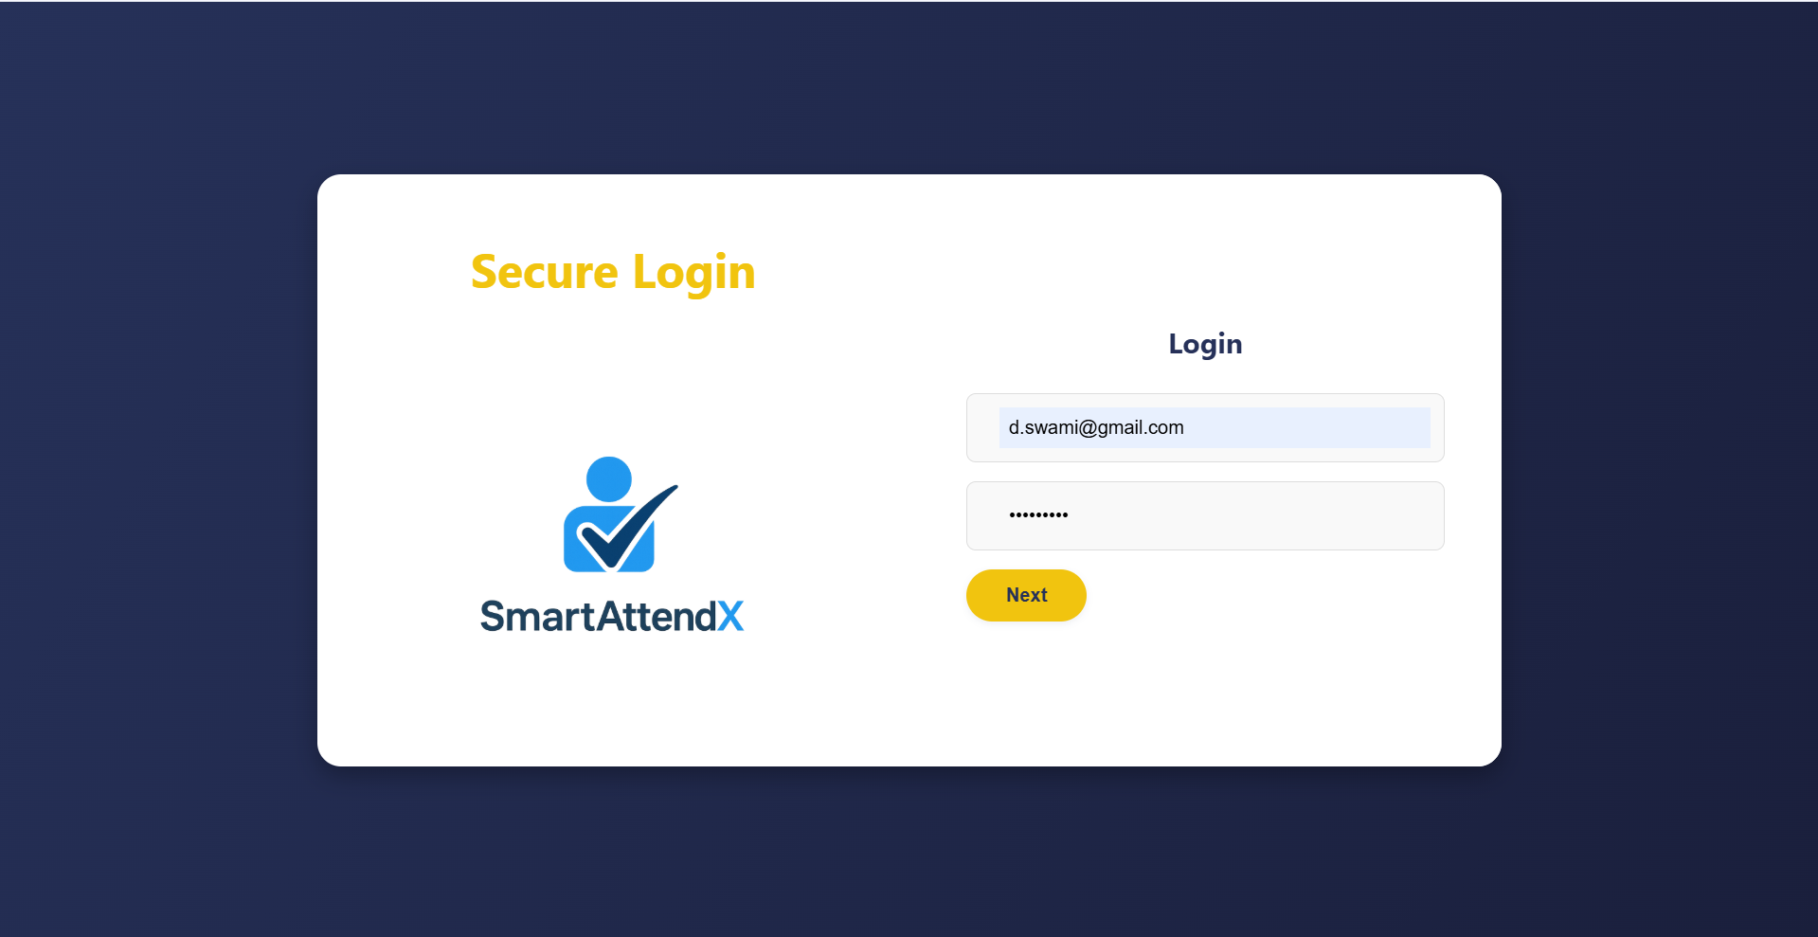

- Admin Dashboard Interface:

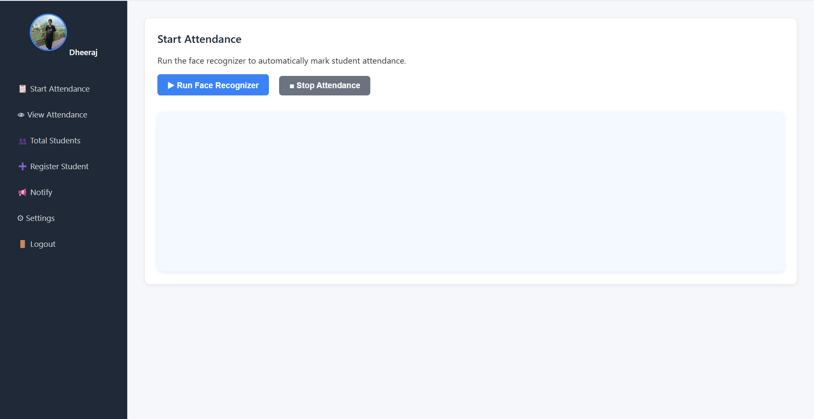

- Student Registration Form:

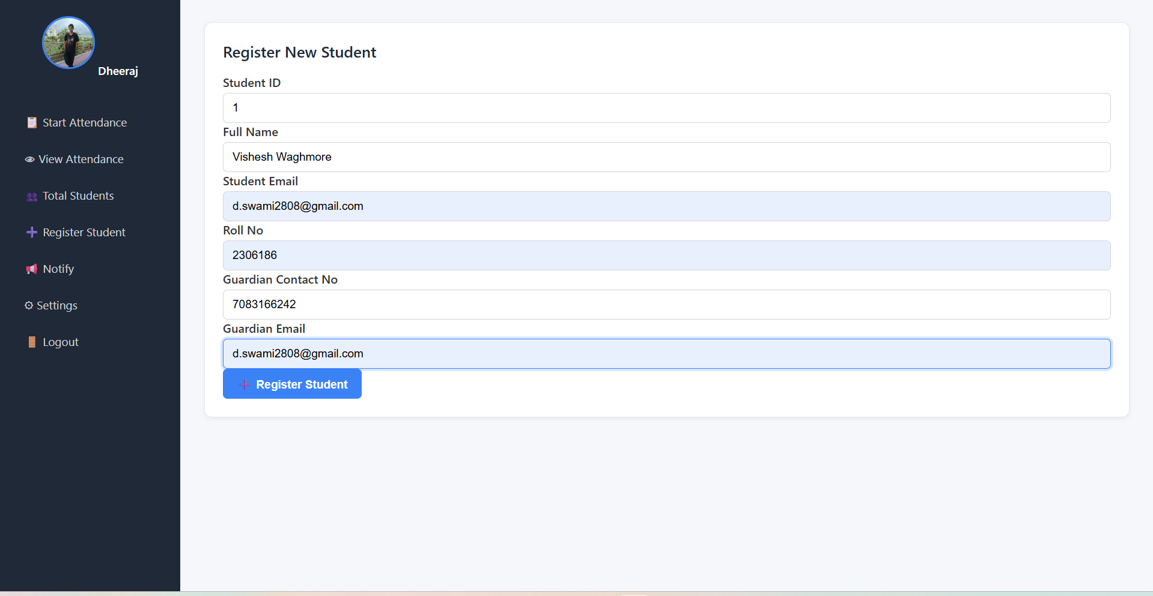

- Capturing Face (20 Images For Model Train)

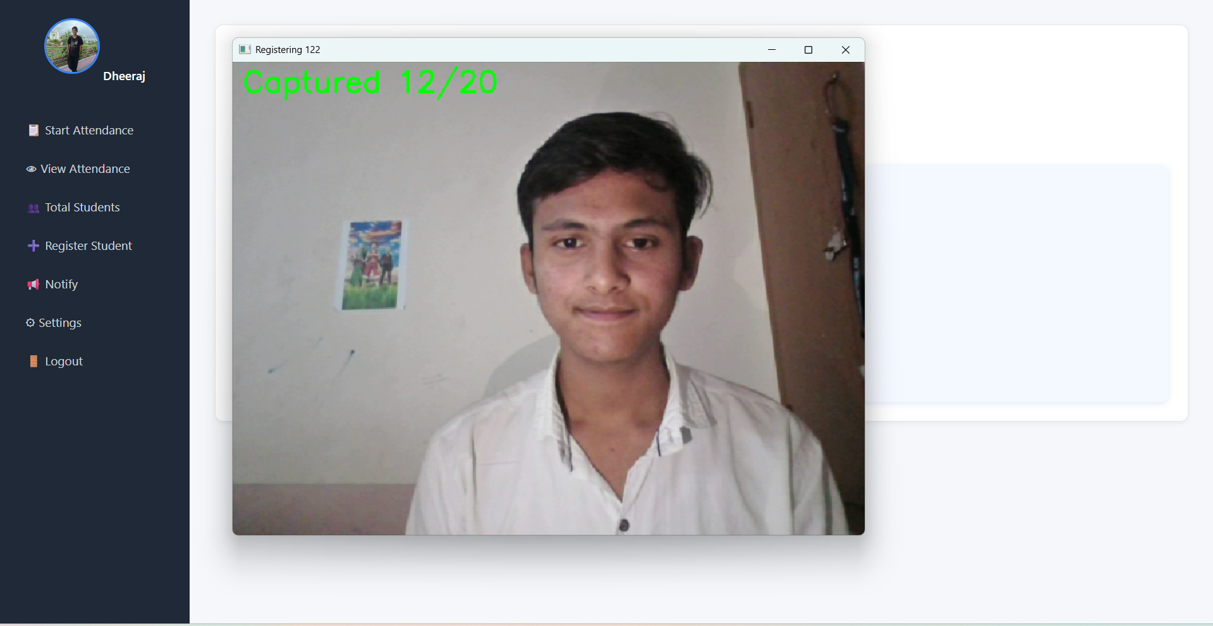

- Face Recognition Window:
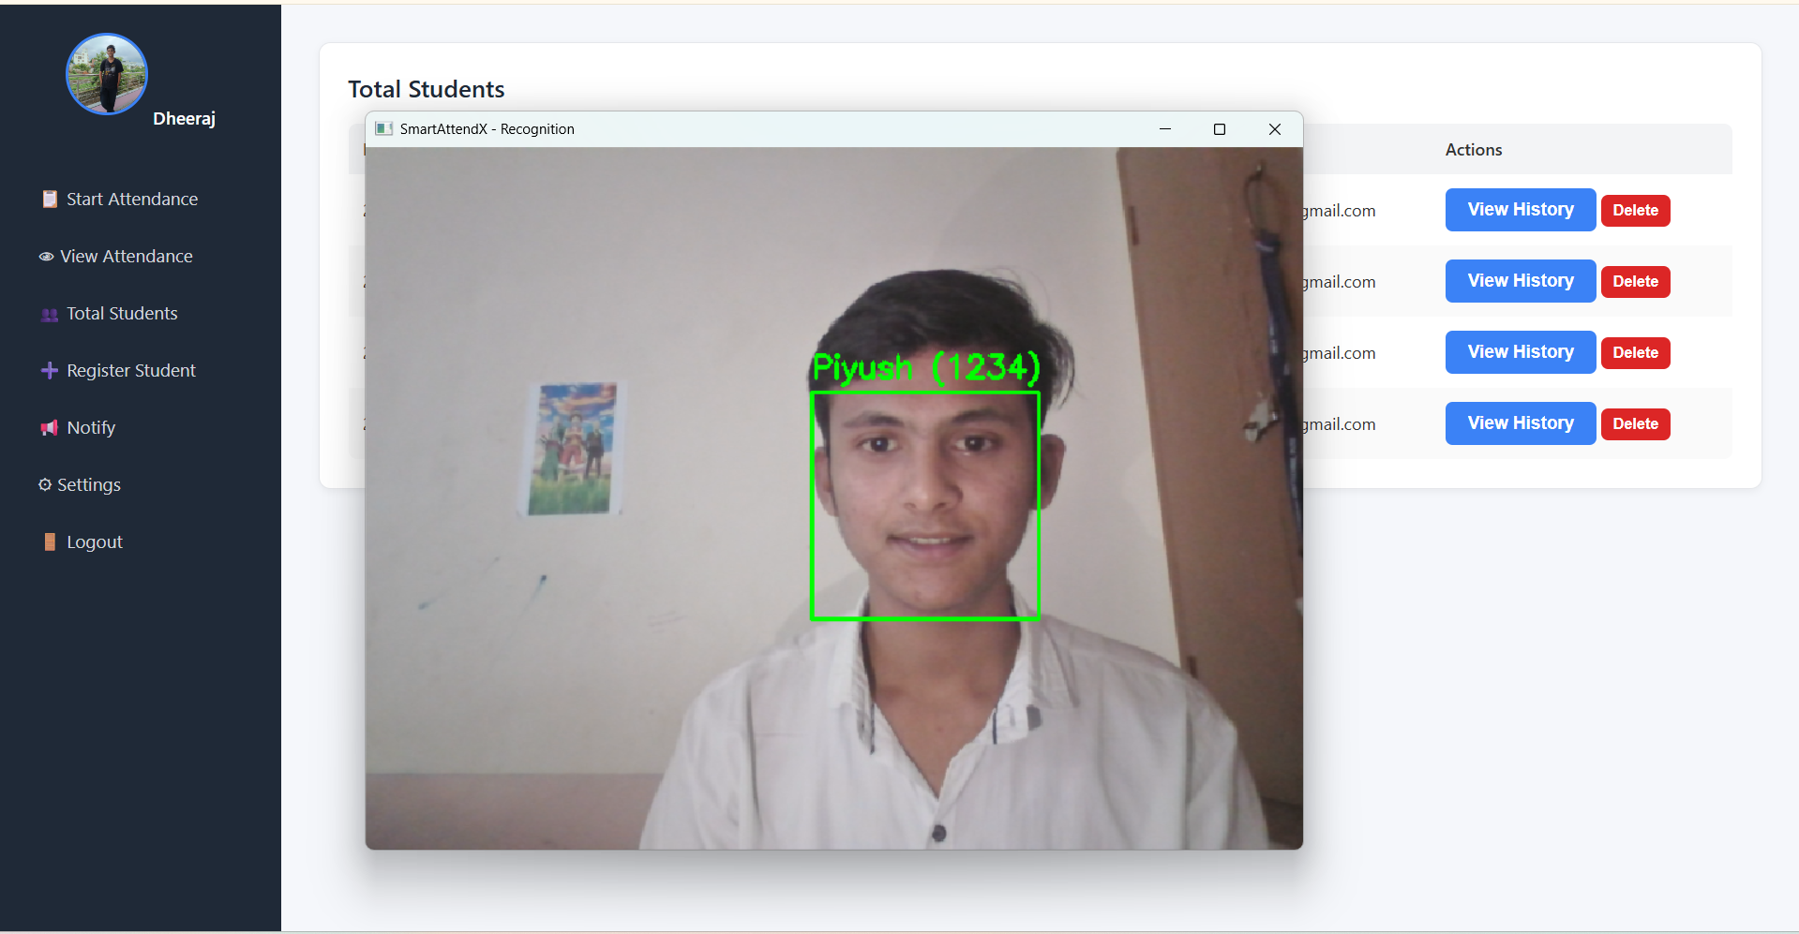

- View Attendance

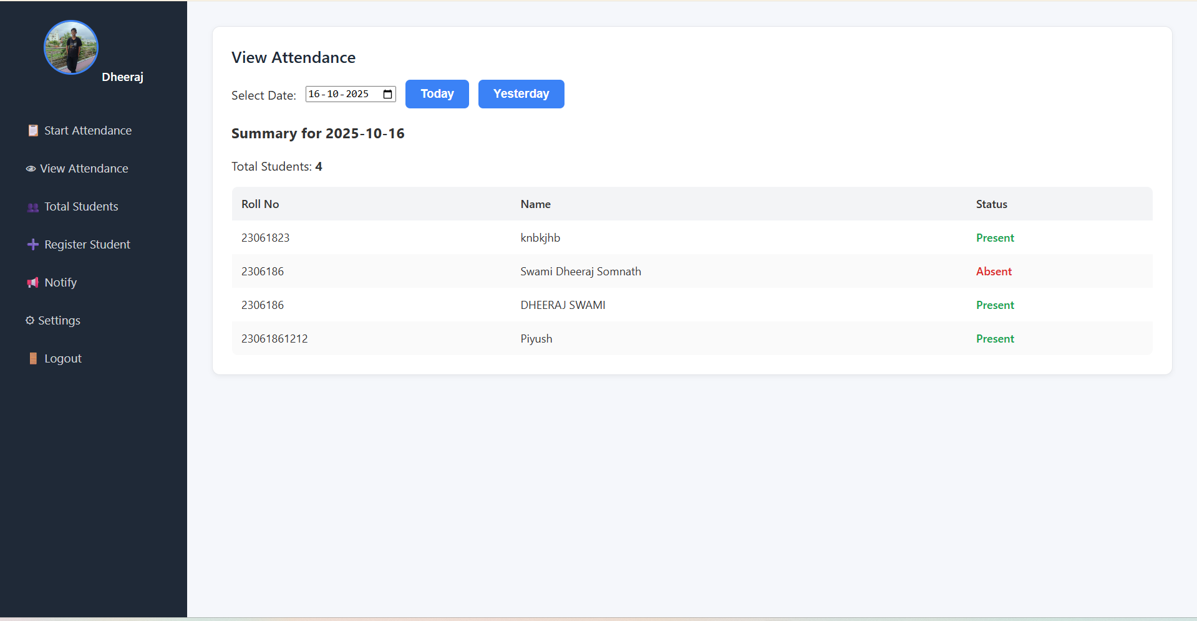

- Monthly Attendence Piechart

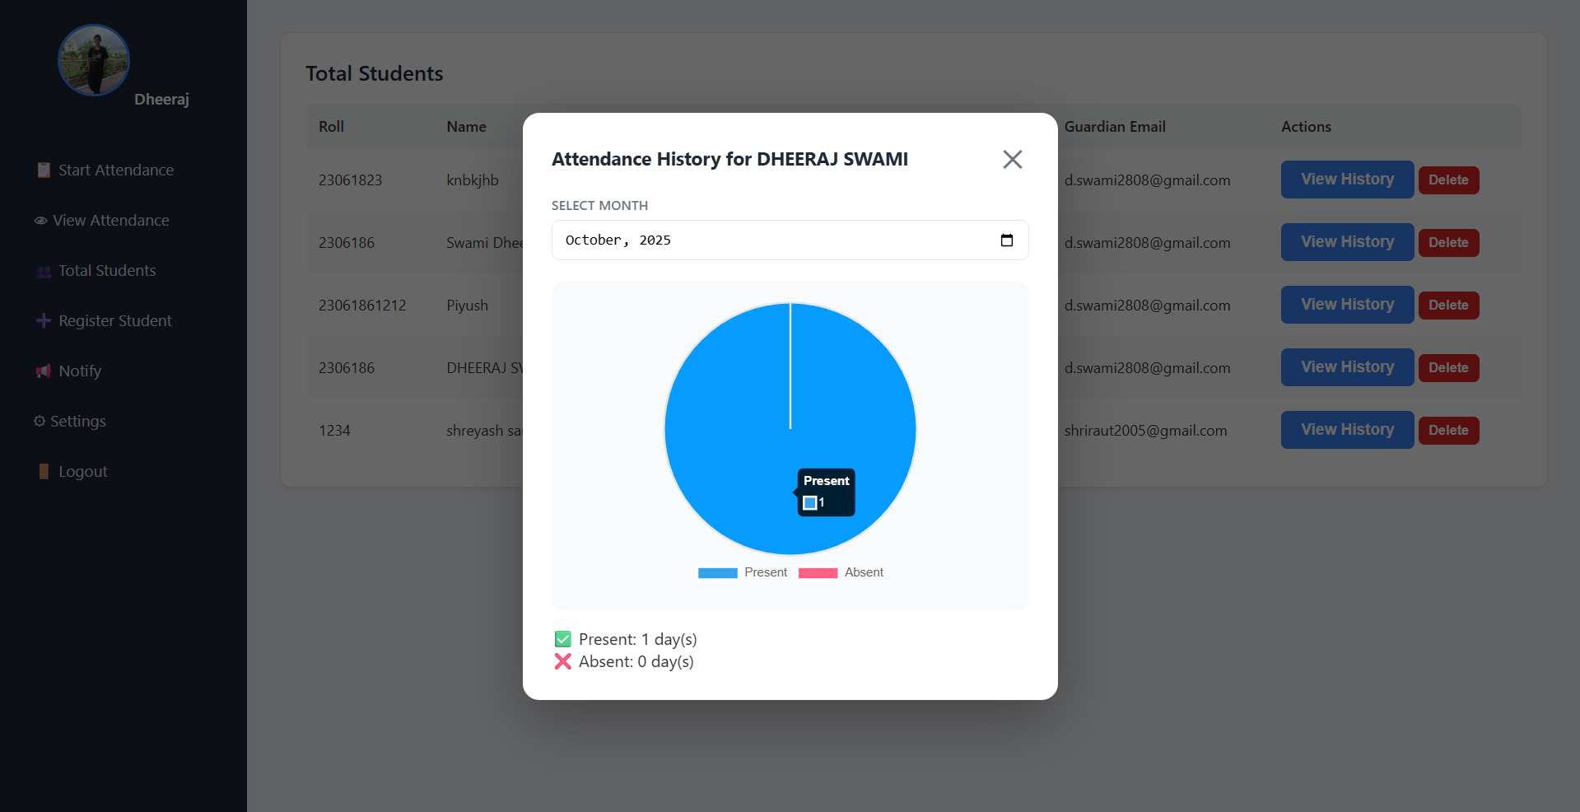

3. Result Analysis:
- After several rounds of testing under different environmental conditions (lighting, background noise, and camera quality), the following results were observed:

Parameter | Result / Performance
Average Face Recognition Time | 2.3 seconds
Average Voice Verification Time | 2.7 seconds
Total Recognition Time per Student | ~5 seconds
Face Recognition Accuracy | 96%
Voice Authentication Accuracy | 88%
Combined Dual Verification Accuracy | 92%
Email Delivery Success Rate | 100%
Average CPU Utilization | 45% (on Core i5, 8GB RAM)

From the above results and testing outcomes, the following key points can be discussed:
- The face_recognition library provided high accuracy due to its deep learning-based encoding system.
- Voice verification successfully reduced proxy cases by adding a second authentication layer.
- The Flask web interface allowed admins to handle attendance conveniently from any computer.
- Flask-Mail integration improved communication by automatically informing students and guardians.
- Data visualization using Chart.js simplified performance monitoring and attendance analysis.

- Multi-admin support ensured complete data isolation between institutions or departments.
The system achieved its design goals of automation, security, and user-friendliness.
It demonstrated consistent performance across multiple test runs, confirming its practicality for deployment in academic or organizational environments.

CHAPTER 9

ADVANTAGES AND DISADVANTAGES

Every software system has strengths and limitations depending on its design and technology.
SmartAttendX, developed using face and voice recognition, provides a reliable, contactless, and intelligent solution for managing attendance.
This chapter highlights the key advantages and disadvantages observed during its implementation and testing.

ADVANTAGES
    - Dual Biometric Verification: Combines face and voice recognition for two-level authentication, ensuring higher accuracy and preventing proxy attendance.
    - Automation and Time Efficiency: Automatically detects, verifies, and marks attendance within seconds, saving time and effort for administrators.
    - Instant Notifications: Uses Flask-Mail to send real-time attendance updates to students and guardians.
    - High Accuracy: Face recognition achieves up to 96% accuracy, and combined with voice verification, overall accuracy exceeds 92%.
    - User-Friendly Dashboard: A simple and responsive interface built with HTML, CSS, and JS, allowing easy operation and real-time analytics.
    - Cost-Effective: Uses only open-source tools and existing hardware (webcam and mic), making it affordable for institutions.
    - Secure Data Management: Data is stored locally in SQLite, protected by admin authentication and session management.
    - Multi-Admin Support: Each admin manages their own students and attendance data independently.
    - Paperless and Environment Friendly: Replaces manual registers with digital records, reducing paperwork and storage needs.

9.2 DISADVANTAGES

    - Environment Dependence: Recognition accuracy can drop under poor lighting or noisy surroundings.
    - Voice Variability: Illness or background noise may affect voice authentication results.
    - Initial Setup Time: Registering students requires capturing multiple face images and a voice sample.
    - Internet Dependency: Email notifications require a stable internet connection.
    - Hardware Sensitivity: Low-quality webcams or microphones may reduce performance.
    - Privacy Concerns: Storing biometric data (face and voice) may raise privacy-related concerns.
    - Limited Mobile Support: Currently optimized for desktops; mobile application not yet implemented.

CHAPTER 10

CONCLUSION

The project SmartAttendX – Face and Voice Recognition Based Smart Attendance Management System successfully achieves its goal of automating attendance through dual biometric verification using face and voice recognition.
The system provides a secure, contactless, and reliable way to record attendance, eliminating manual errors and proxy marking. It integrates AI-based recognition, a Flask web framework, and a SQLite database to offer an efficient and easy-to-use solution.
Testing showed that SmartAttendX performs accurately and quickly, marking attendance within seconds and notifying students and guardians instantly through email alerts. The web dashboard simplifies management, viewing, and analysis of attendance records.
This project demonstrates how modern technologies like AI and Machine Learning can be effectively applied to solve real-world institutional challenges. It promotes a paperless, transparent, and time-saving attendance process.
In conclusion, SmartAttendX is a smart, cost-effective, and scalable system that enhances efficiency and accuracy. With future enhancements such as cloud integration and mobile access, it can become a complete and advanced attendance management platform.

CHAPTER 11

FUTURE SCOPE

The SmartAttendX system has been successfully developed and tested as an intelligent, dual-biometric attendance solution. Although it fulfills its primary objectives, there is still significant potential for improvement and expansion in the future.
In the coming versions, the system can be enhanced with additional technologies and advanced features such as:
    - Mobile Application Integration: Developing an Android or iOS app to allow admins and students to access attendance records and reports from anywhere.
    - Cloud-Based Storage: Implementing cloud integration to enable centralized database management and remote access across multiple campuses or departments.
    - Deep Learning Models: Using advanced neural networks to further improve face and voice recognition accuracy, even under low-light or noisy conditions.
    - Geo-Location and RFID Support: Adding GPS or RFID-based validation to ensure students are physically present at the location during attendance marking.
    - Integration with Institutional Systems: Connecting SmartAttendX with existing Learning Management Systems (LMS) or HR modules for seamless data sharing and reporting.
    - Enhanced Security and Encryption: Strengthening biometric data protection through encryption and secure authentication mechanisms.
By implementing these future enhancements, SmartAttendX can evolve into a complete, cloud-enabled, and enterprise-level attendance management platform suitable for both academic and corporate environments.

CHAPTER 12

REFRENCES

    - Ian Goodfellow, Yoshua Bengio, and Aaron Courville — Deep Learning, MIT Press, 2016.
    - Gary Bradski and Adrian Kaehler — Learning OpenCV 3, O’Reilly Media, 2017.
    - Research Paper: Hybrid Biometric System Using Face and Voice Recognition for Attendance Automation, IJARCCE, Vol. 10, Issue 4, 2024.
    - Python Official Documentation: https://www.python.org/doc/
    - Flask Framework: https://flask.palletsprojects.com/
    - face_recognition Library: https://github.com/ageitgey/face_recognition
    - Librosa Audio Processing: https://librosa.org/doc/latest/
    - SQLite Database: https://www.sqlite.org/docs.html
    - Flask-Mail Documentation: https://pythonhosted.org/Flask-Mail/
    - Chart.js Visualization Library: https://www.chartjs.org/docs/

